

**LAB 7**

**TASK 1:**

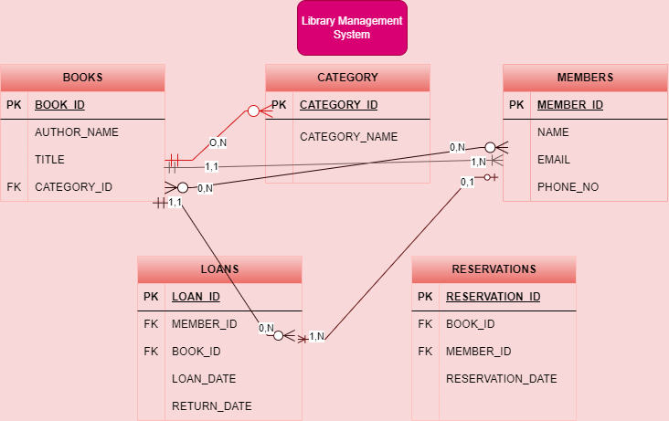

**Explanation:**

**Category:** Many books can fall under a single category (for example, there may be a lot of books in the "Science Fiction" category).

**Books:** A book can only be classified into one category (for example, "Science Fiction").

**Members to Books:** A member can reserve many books, but it's optional (zero or more). A book can be reserved by many members, but it is also optional (zero or more).

**Many Optional (Members)**: A member can reserve zero or many books. The "zero" indicates that a member may choose not to reserve any books, so it's optional on the side of Members.

**Many Optional (Books)**: A book can be reserved by zero or many members. Similarly, a book may have zero reservations, so it's optional on the side of Books as well.

**Books to Members: Each book can be borrowed by exactly one member at a time**, meaning that whenever a book is borrowed, it **must** be associated with a member. This makes therelationship **mandatory** for books. **A member can borrow one or many books**, meaning a member **must** borrow at least one book, and can borrow multiple books. This makes the relationship **mandatory** for members in the borrowing context.

**Mandatory for Loans**: A loan cannot exist without a book being loaned, so it’s mandatory for loans to reference a book.

**Optional for Books**: A book does not need to have a loan record to exist in the library system (it can be available for borrowing but not yet borrowed), making the relationship optional from the perspective of books.

**Optional for Members**: A member does not have to borrow books (optional), so a member can exist without any loans.

**Mandatory for Loans**: A loan cannot exist without being linked to a member. Every loan must be tied to one member.

**TASK 2:**

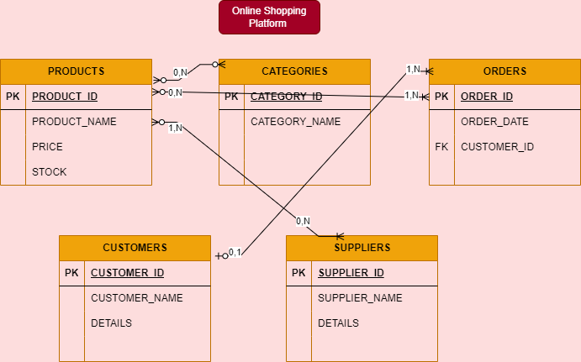

**Explanation:**

**Relation between products & categories:**

**Many Optional (Products)**: A product **can belong to one or many categories**, but it's possible for a product to exist without being assigned to any category (e.g., new products). This makes the relationship **optional** for products.

**Many Optional (Categories)**: A category can contain **zero or many products**, meaning a category might not yet have any products assigned to it. This makes the relationship **optional** for categories as well.

**Relation between customers & orders:**

**One Optional (Customers)**:A customer **may or may not place an order**. For example, a customer might be registered on the platform but hasn't placed any orders yet, making the relationship **optional** on the customer side.

**Many Mandatory (Orders)**:Each order **must** be placed by one and only one customer. There cannot be an order without an associated customer, so the relationship is **mandatory** on the order side.

**Relation between products & orders:**

**Many Optional (Products)**: A product **can exist without being included in any order** (e.g., a product may be listed but not yet purchased), making the relationship **optional** for products.

**Many Mandatory (Orders)**: An order **must contain at least one product** to be valid, so the relationship is **mandatory** for orders. An order cannot exist without products.

**Relation between suppliers & products:**

**Many Mandatory (Suppliers)**: A supplier can provide **zero or many products**, but once a product is supplied, it must have at least one supplier associated with it. Thus, each product must be supplied by at least one supplier, making the relationship **mandatory** for products.

**Many Optional (Products)**: A product **can exist without being associated with a supplier** (e.g., a product might be in development or not yet released), making the relationship **optional** for suppliers.

**TASK 3:**

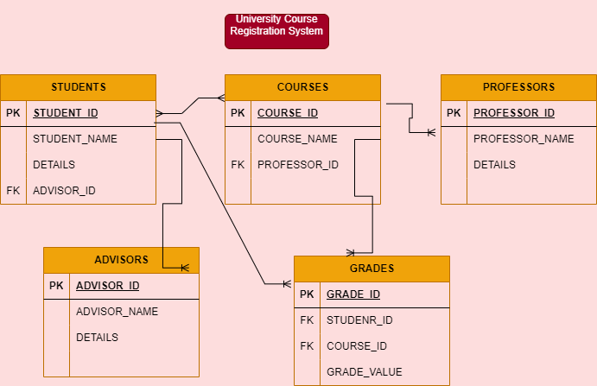

**Explanation:**

**Relation between students & courses:**

A student can register for one or many courses, and each course can have one or many students.

**Relation between courses & professors:**

Each course is taught by one professor, but a professor can teach zero or many courses.

**Relation between students & advisors:**

Every student is assigned to exactly one advisor, and each advisor can advise one or many students.

**Relation between grades & students:**

Each grade is associated with one student, but a student can have grades for many courses.

**Relation between grades & courses:**

Each grade is associated with one course, but a course can have grades for many students.